CHAPTER 5

STRUCTURAL ANALYSIS

Once the preliminary design is completed, the structure undergoes analysis for various load cases and combinations. The results from this analysis are used to refine the section designs, incorporating more precise data on load effects. These sections are iteratively adjusted to comply with code requirements and professional standards.

5.1 METHOD OF ANALYSIS
ETABS is a structural analysis and design software that can be used to analyze a building structure. The analysis methods available in ETABS include:

5.1.1 Linear Static Analysis:
ETABS is a software tool for structural analysis and design, specifically tailored for analyzing building structures. It offers various analysis methods to evaluate the behavior and performance of buildings.

5.1.2 Multi-Step Static Analysis:
This type of analysis is used to analyze structures that are subjected to loads that are applied in a series of steps. For example, a structure that is subjected to wind loads that increase gradually over time would be analyzed using multi-step static analysis.

5.1.3 Dynamic Analysis:
Structures that are subject to dynamic loads, such as impact and earthquake loads, are analyzed using this kind of analysis. Linear or nonlinear techniques can be used for dynamic analysis. The kind of structure being examined and the kinds of stresses it is subjected to determine the kind of analysis employed by ETABS. For instance, linear static analysis can be used to examine a straightforward beam that is subjected to gravitational stresses. Nonlinear static analysis, however, can be required to examine a complex structure that is subjected to dynamic loads.

The following steps are involved in performing an analysis in ETABS:
- Create the structural model.
- Define the loads and boundary conditions.
- Select the analysis method.
- Run the analysis.
- Analyze the results.
□ Create the structural model:
This initial step involves defining the geometry of the structure within ETABS. It includes specifying the layout of beams, columns, slabs, walls, and other structural elements. The model also incorporates information about material properties such as concrete, steel, etc., and how these elements are connected or interact within the structure.

□ Define the loads and boundary conditions:
In this step, the engineer specifies the various loads that act on the structure. These can include dead loads (self-weight of the structure), live loads (occupant loads), wind loads, earthquake loads, temperature effects, etc. Boundary conditions are also set to define how the structure interacts with its supports or surroundings, such as fixed supports, pinned supports, and constraints due to adjacent structures.

□ Select the analysis method:
ETABS offers different analysis methods depending on the nature of the structure and the types of loads applied. Common methods include static analysis (linear or nonlinear), dynamic analysis (response spectrum analysis, time history analysis), and nonlinear analysis (pushover analysis, nonlinear time history analysis). The choice of method depends on factors like structural complexity, loading conditions, and design requirements.
□ Run the analysis:
This step involves executing the analysis within ETABS. The software solves the equations derived from the structural model and the specified loads and boundary conditions. During this process E-tabs computes the internal forces, Stresses, deformations and other relevant responses of the structures under the applied loads.

Analyze the results:
After completing the analysis, engineers review and interpret the results generated by ETABS. This process assesses whether the structure meets safety requirements, evaluates its performance under the applied loads, and verifies compliance with design criteria and building codes. This step may involve examining graphical outputs, numerical data, and detailed reports provided by the software to make informed decisions about the structure's design and behavior.

5.2 CALCULATION OF BASE SHEAR

5.2.1 Base Shear Coefficient

Table 1GFT
Horizontal Base shear Coefficient Calculation
As per NBC 105:2020 [MRF]
Height of Building (H) = | 19.200m | (Height of the building from foundation or from top of a rigid basement.)
Seismic Zone Factor (Z) = | 0.3 | Ref (Cl 4.1.4)
Importance Factor (I) = | 1.25 | Ref (Cl 4.1.5)
Soil Type = | B | Soil type B
Structure type = | Moment resisting concrete frame
(K_{t})= | 0.075 | Ref (Cl 5.1.2)
Approximate Fundamental Period of Vibration:
(T₁) = K_{t}H^{0.75}= | 0.688Sec | Ref (Cl 5.1.2)
Amplification of approximate period:
T1=1.25*T1= | 0.868 | Ref (Cl 5.1.3)
From Rayleighs
T₁= | 0.680Sec | Ref. no. Cl. 5.1
Method of Analysis= | Response Spectrum Analysis
Lower period of flat part of spectrum
T_{a} = | 0.1 | Ref (Cl 4.1.2)
Lower period of flat part of spectrum
T_{c} = | 0.7 | Ref (Cl 4.1.2)
Peak spectral acceleration normalized by PGA
α = | 2.5 | Ref (Cl 4.1.2)
Coefficient that controls the descending branch of the spectrum
K = | 1.8 | Ref (Cl 4.1.2)
Spectral shape factor
C_{h}(T) = | 2.5 | Ref (Cl 4.1.2, Eq. 4.1(2))
Elastic site spectra for horizontal loading
C(T)=C_{h}(T) Z I= | 0.9375 | Ref (Cl 4.1.1, Eq. 4.1(1))
Elastic site spectra for Serviceability Limit State (SLS)
Cs(T)= 0.2* C(T) = | 0.1875 | Ref (Cl 4.2, Eq. 4.2(1))
Ductility Factor
Ductility factor for Ultimate Limit State (ULS)
R_{μ} = | 4 | Ref (Cl 5.3.1, Table 5-2)
Overstrength Factor
Overstrength factor for ULS
Ωu = | 1.5 | Ref (Cl 5.4.1, Table 5-2)
Overstrength factor SLS
Ωs = | 1.25 | Ref (Cl 5.4.2, Table 5-2)
Horizontal base shear coeffieicent for ULS,
C_{d}(T₁)=C(T₁)/(Rμ*Ωu)= | 0.156 | Ref (Cl 6.1.1, Eq. 6.1(1))
Horizontal base shear coeffieicent for SLS,
C_{d}(T₁)=Cs(T₁)/Ωs = | 0.150 | Ref (Cl 6.1.2, Eq. 6.1(2))
Exponent related to the structural period (K)
K = | 1.090 | Ref (Cl 6.3)
Accidental Eccentricity
e = | 0.100 | Ref (Cl 5.7)

5.3. BASE REACTION SCALING:
When the design base shear (VR) obtained by combining the modal base shear forces is less than the base shear (V) calculated using Equivalent Static Method, the member forces, story shear forces & base reactions obtained from the MRS method shall be multiplied by VR/V.
Where, V = Base Shear determined from Equivalent Static Method VR = Base Shear determined from Modal Combination

Table 2: Base Reaction
TABLE: Base Reactions
Output Case | Case Type | Step Type | Step Number | FX | FY | FZ | MZ
 |  |  |  | kN | kN | kN | kN-m
Modal | LinModEigen | Mode | 1 | 384.4772 | -3106.29 | 0 | -60040.3
Modal | LinModEigen | Mode | 2 | 4016.867 | 569.841 | 0 | -87598.9
Modal | LinModEigen | Mode | 3 | 489.504 | -2092.92 | 0 | 28933.42
Modal | LinModEigen | Mode | 4 | 319.555 | -9496.47 | 0 | -183090
Modal | LinModEigen | Mode | 5 | 13668.38 | 8042.563 | 0 | -377578
Modal | LinModEigen | Mode | 6 | -14836.7 | 7352.433 | 0 | 265416.1
Modal | LinModEigen | Mode | 7 | -461.667 | -11852.7 | 0 | -257593
Modal | LinModEigen | Mode | 8 | -937.271 | -16323.1 | 0 | 72575.03
Modal | LinModEigen | Mode | 9 | 1875.935 | -12998.2 | 0 | -228683
Modal | LinModEigen | Mode | 10 | -3344.43 | 14513.78 | 0 | 654322.8
Modal | LinModEigen | Mode | 11 | 55412.89 | -809.679 | 0 | -1212186
Modal | LinModEigen | Mode | 12 | 3329.46 | 28704.11 | 0 | -112223
Dead | LinStatic |  |  | 0 | 0 | 36776.92 | 0
FF | LinStatic |  |  | 0 | 0 | 6066.723 | 0
Wall Load | LinStatic |  |  | 0 | 0 | 21030.5 | 0
LIVE | LinStatic |  |  | 0 | 0 | 14607.87 | 0
EQX ULS | LinStatic |  |  | -9878.81 | 0 | 0 | 263407.3
EQX SLS | LinStatic |  |  | -9483.66 | 0 | 0 | 252871
EQY ULS | LinStatic |  |  | 0 | -9878.81 | 0 | -110263
EQY SLS | LinStatic |  |  | 0 | -9483.66 | 0 | -105853
Roof Live | LinStatic |  |  | 0 | 0 | 0 | 0
SPECX | LinRespSpec | Max |  | 9881.534 | 777.8213 | 0 | 259376.6
SPECY | LinRespSpec | Max |  | 954.4783 | 9874.791 | 0 | 157404.3
Water Tank | LinStatic |  |  | 0 | 0 | 0 | 0
1.2DL+1.5LL | Combination |  |  | 0 | 0 | 98560.77 | 0
DL+0.3LL+EQX (ULS) | Combination |  |  | -9878.81 | 0 | 68256.5 | 263407.3
DL+0.3LL-EQX (ULS) | Combination |  |  | 9878.808 | 0 | 68256.5 | -263407
DL+0.3LL+EQY (ULS) | Combination |  |  | 0 | -9878.81 | 68256.5 | -110263
DL+0.3LL-EQY (ULS) | Combination |  |  | 0 | 9878.808 | 68256.5 | 110263.4
DL+0.3LL+SPECX | Combination | Max |  | 9881.534 | 777.8213 | 68256.5 | 259376.6
DL+0.3LL+SPECX | Combination | Min |  | -9881.53 | -777.821 | 68256.5 | -259377
DL+0.3LL+SPECY | Combination | Max |  | 954.4783 | 9874.791 | 68256.5 | 157404.3
DL+0.3LL+SPECY | Combination | Min |  | -954.478 | -9874.79 | 68256.5 | -157404
DL+LL | Combination |  |  | 0 | 0 | 78482.01 | 0

 |  | Mode | 1 | 384.4772 | -3106.289 | 0 |  |  | -60040.2587 | 0 | 0 | 0
 |  | Mode | 2 | 4016.8672 | 569.841 | 0 |  |  | -87598.9115 | 0 | 0 | 0
 |  | Mode | 3 | 489.504 | -2092.9235 | 0 |  |  | 28933.4243 | 0 | 0 | 0
5.4 CENTRE OF MASS AND CENTRE OF RIGIDITY CHECK |  | Mode | 4 | 319.555 | -9496.4658 | 0 |  |  | -183090.0128 | 0 | 0 | 0
Table 3: Centre of Mass and Rigidity  TABLE: Center Of Mass And Rigidity  Story Diaphragm XCCM YCCM XCR YCR  m m m m ex ey ex% ey %  Story1 D1 0 0 0 0 0 0  Story2 D2 8.9825 22.4829 7.6807 22.2679 1.302 0.215 2.232222 0.126  Story3 D3 10.153 22.4843 7.2153 22.259 2.938 0.2253 9.32056 1.20  Story4 D4 9.0147 22.483 7.0145 22.2264 2 0.2566 6.11222 0.04  Story5 D5 9.015 22.4827 7.0814 22.1967 1.934 0.286 5.74222 0.36  Story6 D6 9.0244 22.5041 7.2098 22.2885 1.815 0.2156 5.08111 0.5  Story7 D7 3.4631 22.5 2.6748 22.4755 0.788 0.0245 4.379444 0.012 |  | Mode | 5 | 13668.3824 | 8042.5634 | 0 |  |  | -377578.2465 | 0 | 0 | 0
 |  | Mode | 6 | -14836.6996 | 7352.4334 | 0 |  |  | 265416.1141 | 0 | 0 | 0
 |  | Mode | 7 | -461.6674 | -11852.6778 | 0 |  |  | -257592.6184 | 0 | 0 | 0

5.5 IRREGULARITIES IN BUILDING

5.5.1 Mass Irregularity
According to NBC 105:2020, if the seismic weight of any level is greater than 150% of the seismic weight of the floor below, the structure is deemed to have center of mass abnormalities. Buildings that exhibit mass irregularity are more susceptible to environmental forces such as wind loads, earthquakes, and other disasters, since it can result in structural instability. When catastrophic occurrences occur, irregularities might lead to high-stress zones where the building may fail or collapse.
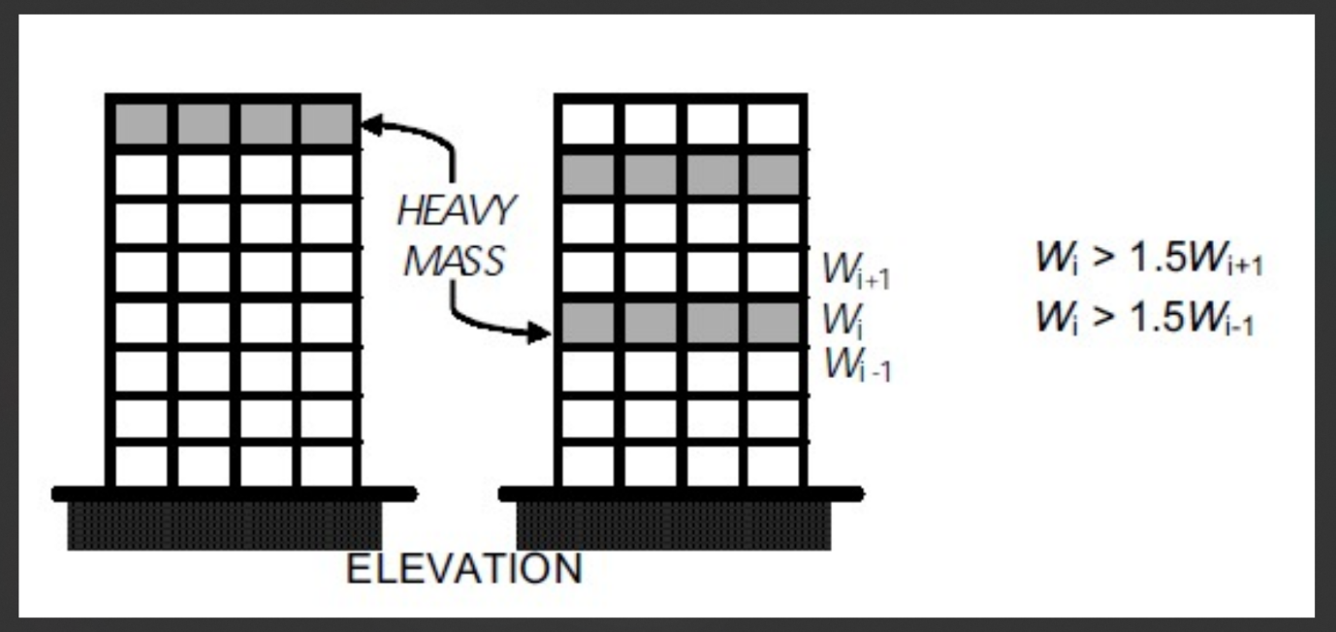

Figure 2: Mass irregularity
Table 4 Mass irregularities check
Story | Mass X or y | Mass <50% of Above or below story
Story6 | 657439 | OK
Story5 | 1151424 | OK
Story4 | 1171160 | OK
Story3 | 1273943 | OK
Story2 | 1177060 | OK
Story1 | 1284695 | OK
Base | 175761 | -

5.5.2 STIFFNESS/RIGIDITY IRREGULARITY
As per NBC 105:2020, Center Stiffness irregularity is present in the structure when the lateral stiffness of a story is less than that of the story above. This irregularity is also known as a soft story. Soft stories are more prone to collapse or deform under lateral loads. In an earthquake, a soft story can fail catastrophically, leading to the collapse of the entire building.

Table 5 Stiffness/Rigidity Irregularity
Story | Stiff x kN/m |  | (Ki <0.7ki+1) | (Ki<(0.8K(i+n)/n)
Story6 | 257177.2 | OK |  | OK
Story5 | 529368 | OK |  | OK
Story4 | 676777 | OK |  | OK
Story3 | 833772.8 | OK |  | OK
Story2 | 938060.5 | OK |  | OK
Story1 | 5838719 | OK |  | OK
Base | 175761 | OK |  | OK

Table 6 Story Stiffness
TABLE: Story Stiffness
Story | Output Case | Stiff Y | (Ki<0.7ki+1) | (Ki<(0.8K(i+n)/n)
 |  | kN/m
Story6 | EQY ULS | 280859.218 | OK |  | OK
Story5 | EQY ULS | 509435.099 | OK |  | OK
Story4 | EQY ULS | 589408.859 | OK |  | OK
Story3 | EQY ULS | 644406.418 | OK |  | OK
Story2 | EQY ULS | 1100383.272 | OK |  | OK
Story1 | EQY ULS | 7524573.709 | OK |  | OK

5.6 STOREY DRIFT CHECK

Storey Drift is the ratio of the inter storey displacement to the storey height under consideration. As per the recommendations of NBC 105: 2020 5.6.3, The ratio of the inter-story deflection to the corresponding story height shall not exceed: 0.025 at ultimate limit state 0.006 at serviceability limit state The deflections shall be obtained by using the effective stiffness properties of the components. It also safeguards the non-structural components of the structure.

Table 7 Storey Drift Check

Drift Criteria (NBC 105:2020)
Design Drift from Etabs in ULS | = | 0.005036 | 0.005536
Allowable drift ULS=.025/Ru | = | 0.00625 | 0.00625
 |  | OK | OK
Design Drift from Etabs in SLS | = | 0.004835 | 0.005314
Allowable Drift SLS | = | 0.006 | 0.006
 |  | OK | OK

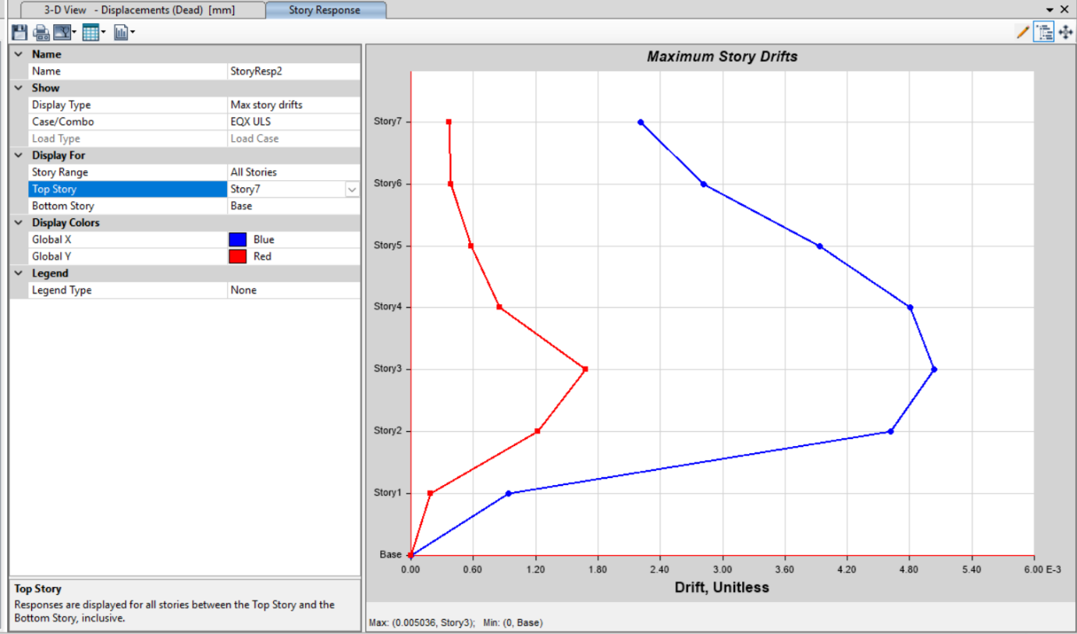
Figure 3 Story Drift EQx ULS

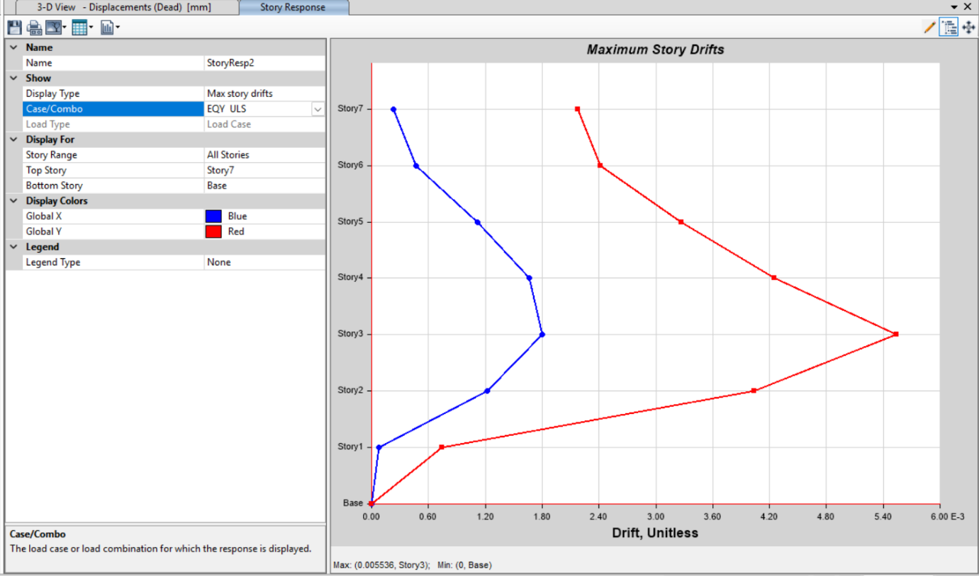
Figure 4Story Drift EQy ULS

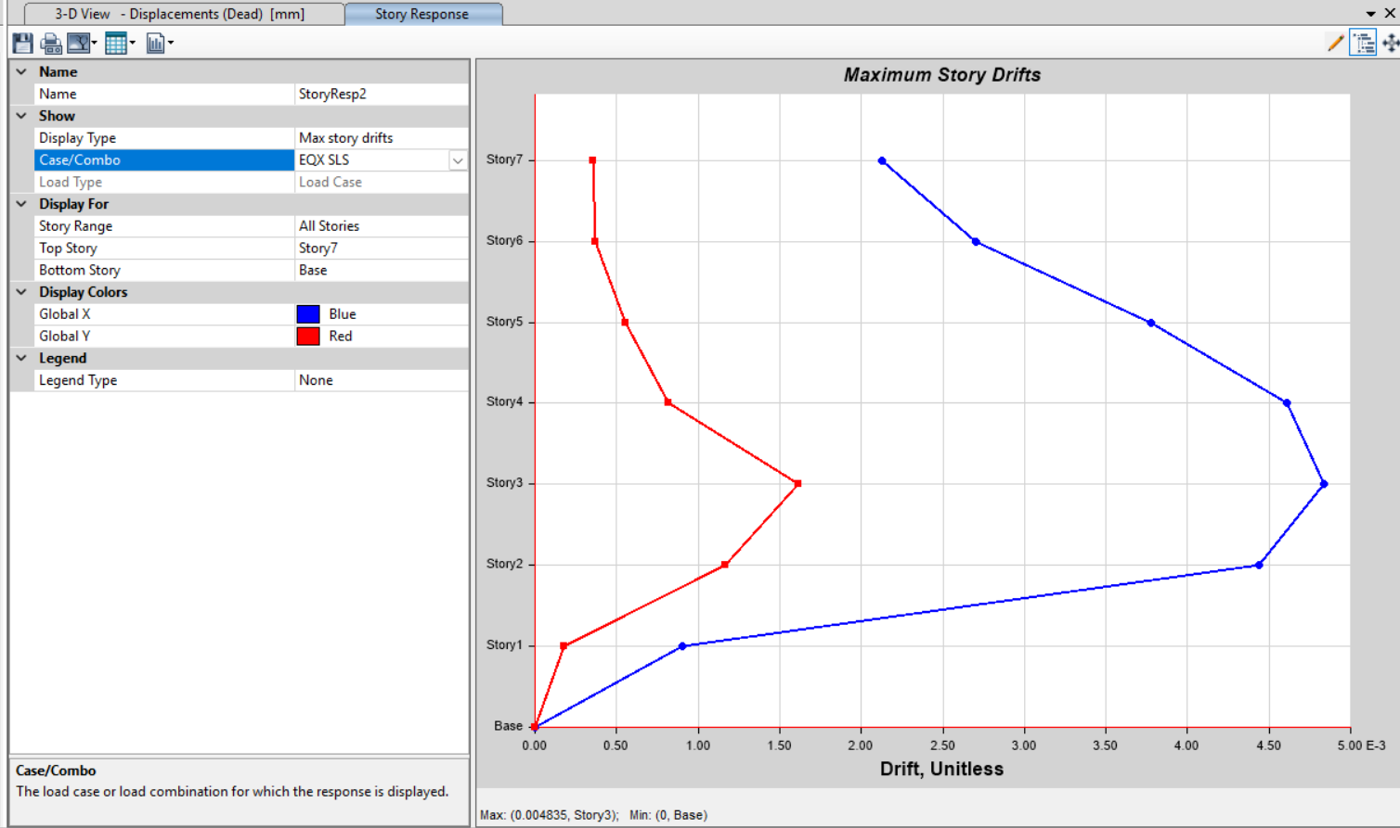
Figure 5 Story Drift EQx SLS

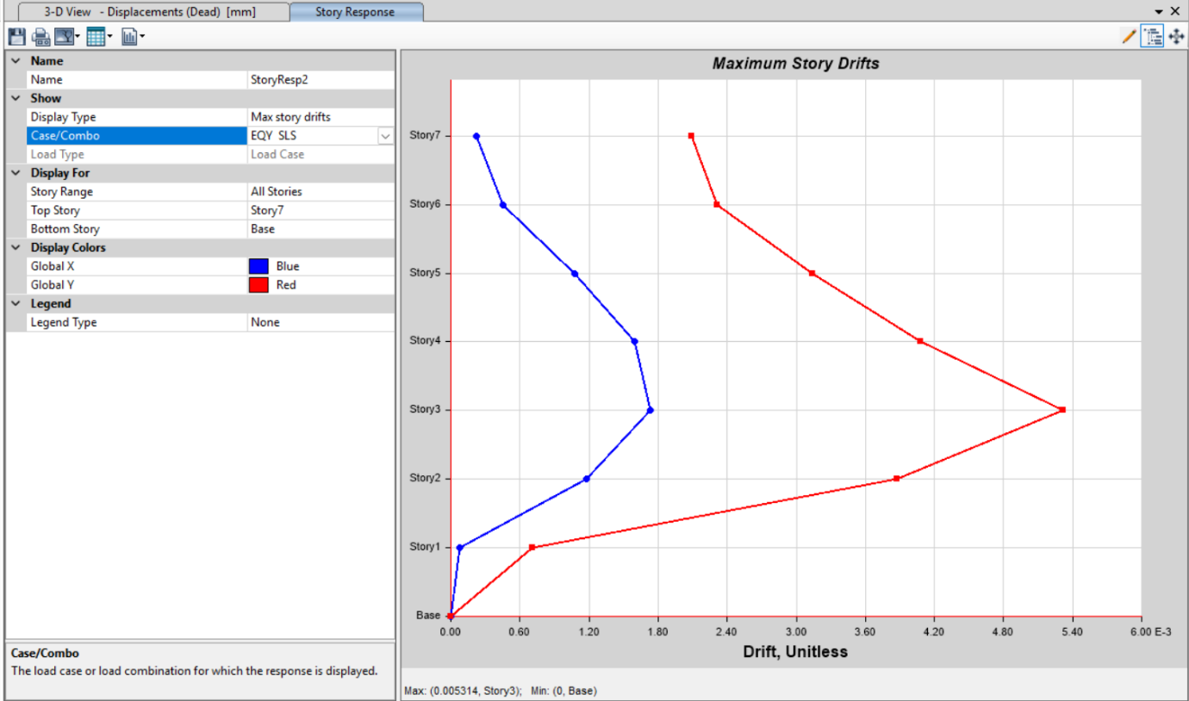
Figure 6 Story Drift EQY SLS

5.7 DISPLACEMENT CHECK
The displacement at the top storey shall not exceed:
0.025 × H at ultimate limit state.
0.006 × H at serviceability limit state.

 | X(mm) | Y(mm)
Design Displacement from Etabs in ULS | 59.683454 | 58.298037
Allowable Ratio ULS | 0.006 | 0.006
Allowable Displacement ULS=0.025H/Ru | 140 | 140
Design Displacement from Etabs in SLS | 57.296116 | 55.96625
Allowable ratio SLS | 0.025 | 0.025
Allowable Displacement SLS=0.006H | 134.4 | 134.4

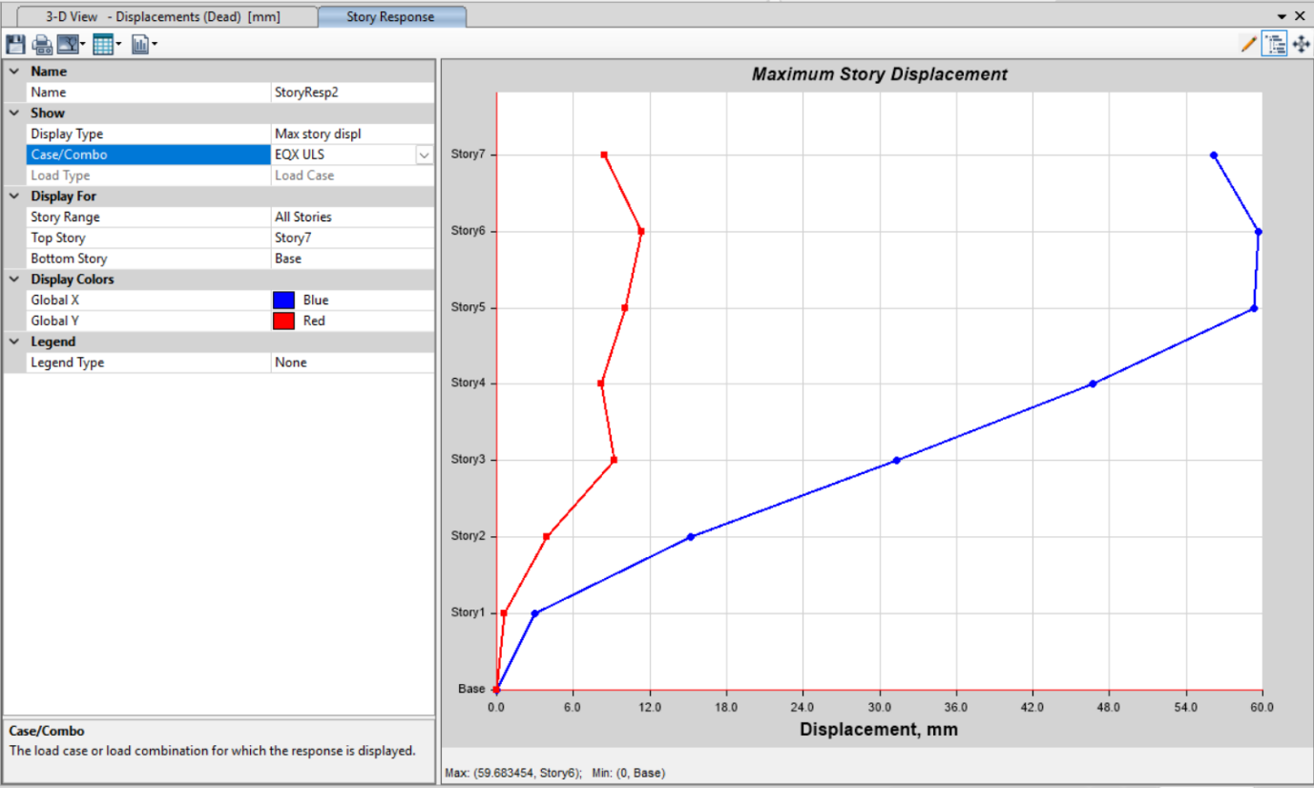
Figure 7 Displacement EQX ULS
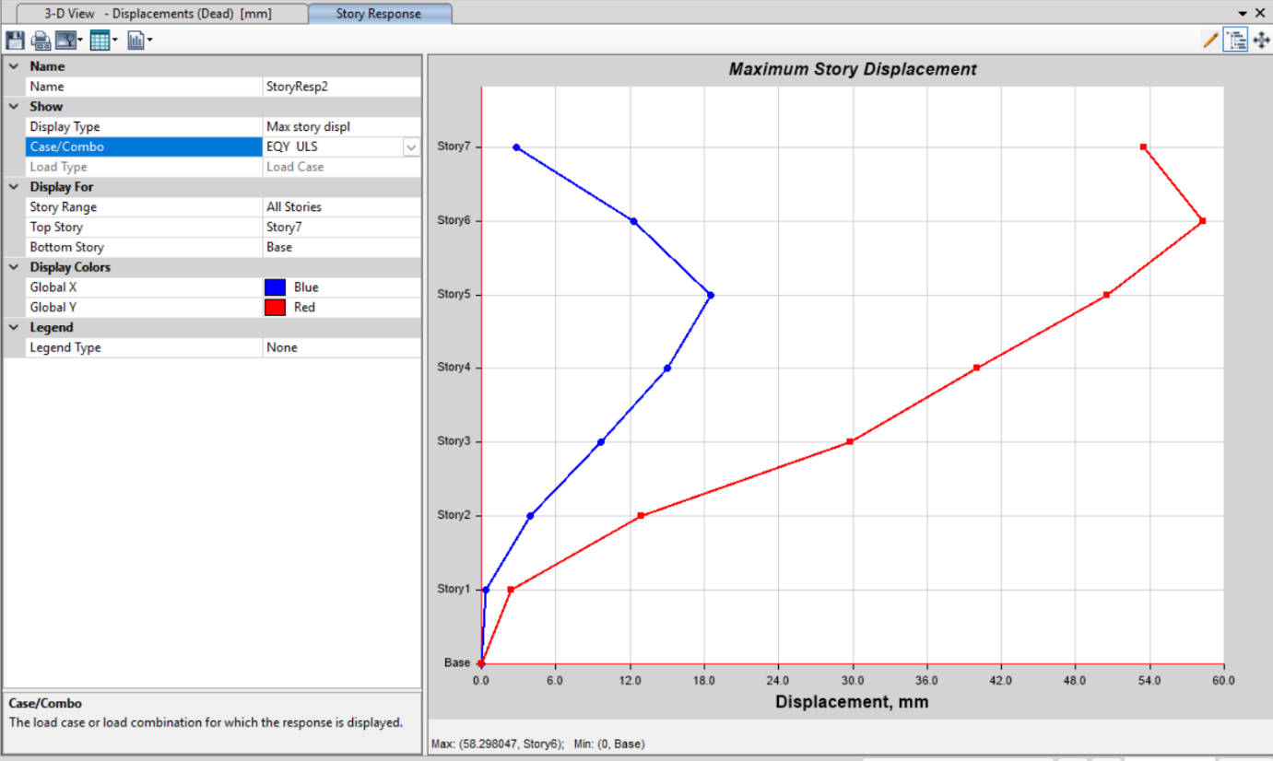
Figure 8 Displacement EQyULS

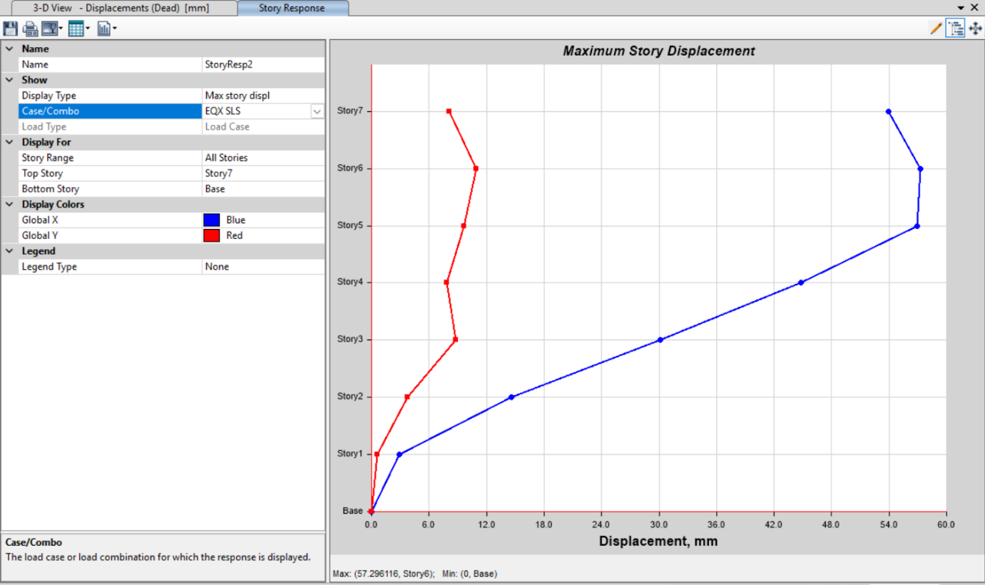
Figure 9 Displacement EQx SLS
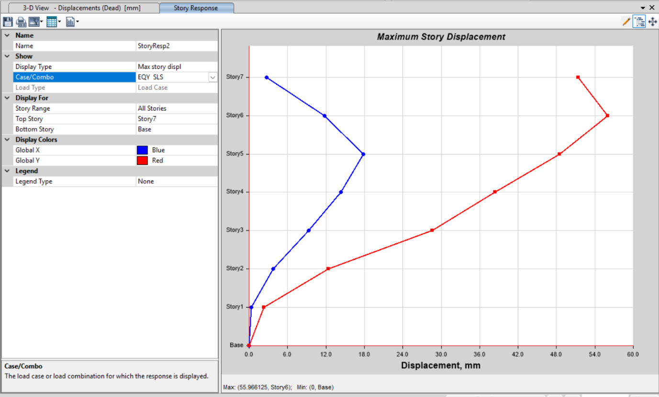
Figure 10 Displacement EQy SLS

5.8 MODAL MASS PARTICIPATING RATIO

The modal mass participating ratio is the effective mass in a structure that is used for the analysis of the earthquake. The number of modes considered for the analysis should be such that the total seismic mass of the structure is at least 90% of the total mass. The first three modes, considered along the principal directions, suggest that the contribution of any further mode to the total seismic mass does not exceed 10%, as per NBC 105: 2020. Part of the check moves the effective masses in the two principal horizontal directions.

Table 8 Modal Participating Mass Ratio
TABLE: Modal Participating Mass Ratios
Case | Mode | UX | UY | UZ | SumUX | SumUY | SumRZ
Modal | 1 | 0.0104 | 0.4779 | 0 | 0.0104 | 0.4779 | 0.1668
Modal | 2 | 0.6653 | 0.0159 | 0 | 0.6757 | 0.4937 | 0.1672
Modal | 3 | 0.0065 | 0.1561 | 0 | 0.6822 | 0.6498 | 0.6566
Modal | 4 | 0.0001 | 0.0593 | 0 | 0.6822 | 0.7091 | 0.6868
Modal | 5 | 0.1098 | 0.007 | 0 | 0.792 | 0.7162 | 0.6968
Modal | 6 | 0.0222 | 0.0325 | 0 | 0.8143 | 0.7486 | 0.7459
Modal | 7 | 0.00001759 | 0.0144 | 0 | 0.8143 | 0.763 | 0.7595
Modal | 8 | 0.0001 | 0.0143 | 0 | 0.8143 | 0.7774 | 0.77
Modal | 9 | 0.0001 | 0.0046 | 0 | 0.8144 | 0.782 | 0.7705
Modal | 10 | 0.0002 | 0.0034 | 0 | 0.8146 | 0.7854 | 0.7927
Modal | 11 | 0.057 | 0.000004008 | 0 | 0.8717 | 0.7854 | 0.7928
Modal | 12 | 0.0001 | 0.0138 | 0 | 0.8718 | 0.7993 | 0.798
Modal | 13 | 0.000004201 | 0.0047 | 0 | 0.8718 | 0.804 | 0.8019
Modal | 14 | 0.00003744 | 0.00004122 | 0 | 0.8718 | 0.8041 | 0.8019
Modal | 15 | 0.00003747 | 0.0024 | 0 | 0.8718 | 0.8064 | 0.8093
Modal | 16 | 0.0584 | 0.00000153 | 0 | 0.9303 | 0.8064 | 0.8093
Modal | 17 | 0.0408 | 0 | 0 | 0.9711 | 0.8064 | 0.8099
Modal | 18 | 0.0033 | 0 | 0 | 0.9744 | 0.8064 | 0.812
Modal | 19 | 0.0006 | 0 | 0 | 0.975 | 0.8064 | 0.8995
Modal | 20 | 0 | 0 | 0 | 0.975 | 0.8064 | 0.8995
Modal | 21 | 0.00000641 | 0 | 0 | 0.975 | 0.8064 | 0.8995

5.9 MODAL PERIOD AND FREQUENCIES

In the modal response spectrum method, The modal period (time for one vibration cycle) and its reciprocal-the frequency. These parameters guide the earthquake resistant design. The base shear forces are determined for each mode, considering the first few significant modes.
Table 9Modal Periods And Frequencies
TABLE: Modal Periods And Frequencies
Case | Mode | Period | Frequency | UX | UY | SumUX | SumUY
 |  | sec | cyc/sec
Modal | 1 | 0.869 | 1.151 | 0.008 | 0.5208 | 0.008 | 0.5208
Modal | 2 | 0.815 | 1.227 | 0.6748 | 0.0136 | 0.6828 | 0.5344
Modal | 3 | 0.754 | 1.327 | 0.0073 | 0.1337 | 0.6901 | 0.6681
Modal | 4 | 0.294 | 3.397 | 0.0001 | 0.0641 | 0.6902 | 0.7322
Modal | 5 | 0.243 | 4.122 | 0.0613 | 0.0212 | 0.7514 | 0.7534
Modal | 6 | 0.242 | 4.14 | 0.0709 | 0.0174 | 0.8223 | 0.7708
Modal | 7 | 0.183 | 5.453 | 2.28E-05 | 0.015 | 0.8224 | 0.7859
Modal | 8 | 0.155 | 6.446 | 4.81E-05 | 0.0146 | 0.8224 | 0.8005
Modal | 9 | 0.133 | 7.503 | 0.0001 | 0.005 | 0.8225 | 0.8055
Modal | 10 | 0.121 | 8.237 | 0.0002 | 0.0043 | 0.8228 | 0.8098
Modal | 11 | 0.117 | 8.522 | 0.0551 | 0.00001176 | 0.8779 | 0.8099
Modal | 12 | 0.114 | 8.805 | 0.0002 | 0.013 | 0.878 | 0.8228
Modal | 13 | 0.092 | 10.922 | 4.1E-06 | 0.0052 | 0.878 | 0.828
Modal | 14 | 0.087 | 11.471 | 3.01E-05 | 0.00004764 | 0.8781 | 0.8281
Modal | 15 | 0.086 | 11.638 | 3.35E-05 | 0.0022 | 0.8781 | 0.8303
Modal | 16 | 0.076 | 13.111 | 0.0539 | 0.000008958 | 0.932 | 0.8303
Modal | 17 | 0.062 | 16.048 | 0.0396 | 0.000004217 | 0.9715 | 0.8303
Modal | 18 | 0.055 | 18.211 | 0.0035 | 0.00001102 | 0.9751 | 0.8303
Modal | 19 | 0.053 | 18.862 | 0.0006 | 0.0016 | 0.9756 | 0.8319
Modal | 20 | 0.044 | 22.799 | 1.42E-05 | 0.1193 | 0.9756 | 0.9512
Modal | 21 | 0.041 | 24.619 | 0 | 0.000000513 | 0.9756 | 0.9512
Maximum allowable value for ∑UX and ∑UY crossing 90% should be less than 33Hertz.

5.10 BEAM-COLUMN CAPACITY RATIO

The beam-column capacity ratio (BCC Ratio) compares the moment capacity of a beam framing into a column at that joint. Essentially, it checks whether the column can handle the forces transmitted by the beams without failing.
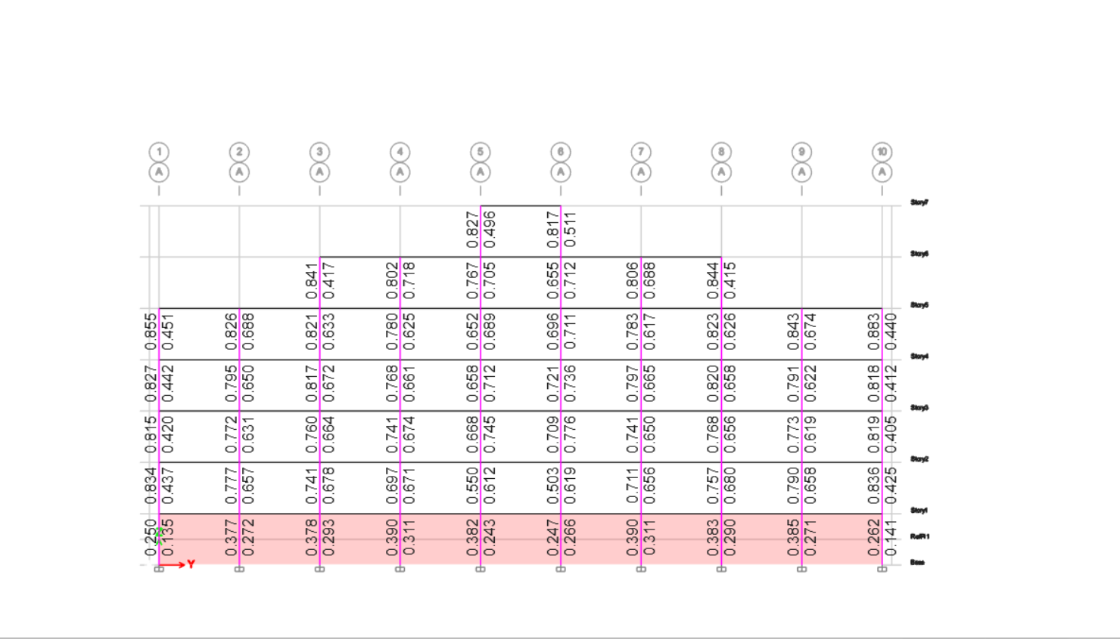
Figure 11Beam-column capacity ratio

The value for BCC Ratio should be less than 1.2 and vice versa for CBB ratio.

5.11 MAT FOUNDATION FROM ETABS

5.11.1 Bearing Capacity Check

Bearing capacity refers to the soil's ability to support the loads applied to it from structures. The allowable bearing capacity was 200kN/M² while we got 120 KN/m²."

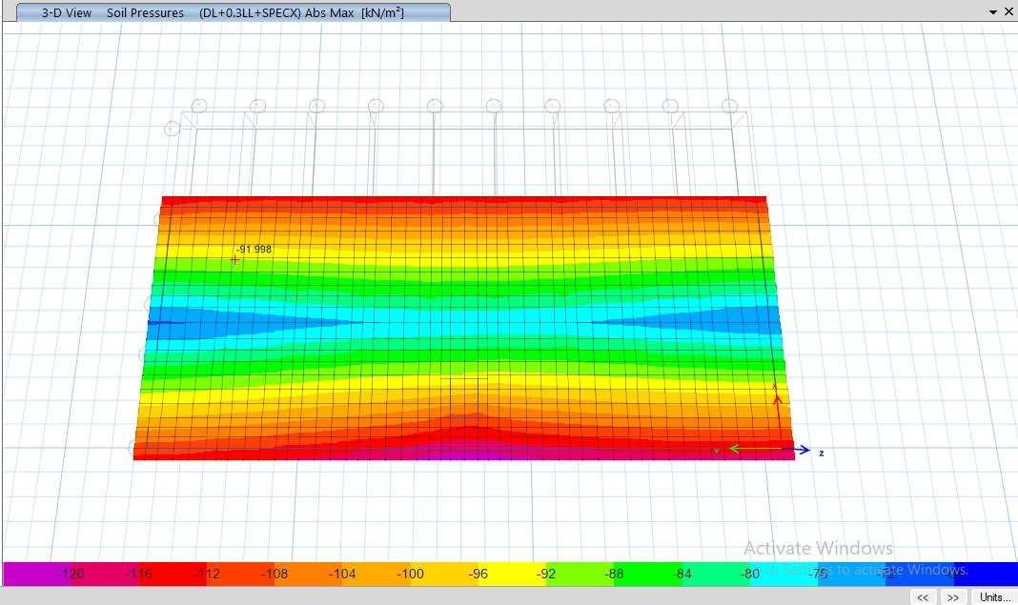
Figure 12 Soil pressure check

5.11.2 Settlement Check
Settlement is defined as the vertical movement of a foundation due to applied loads and soil behavior. The maximum settlement obtained was 12.8 cm while allowable was 65cm.

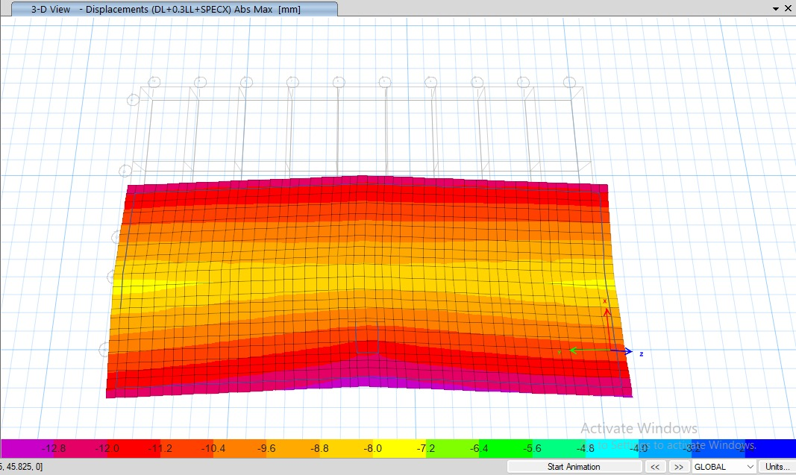
Figure 13 Settlement Check

5.11.3 Punching Shear Check
Punching Shear is a failure where concentrated load near columns causes a shear force that exceeds the footing capacity to resist it. Our punching shear is below 1.00.

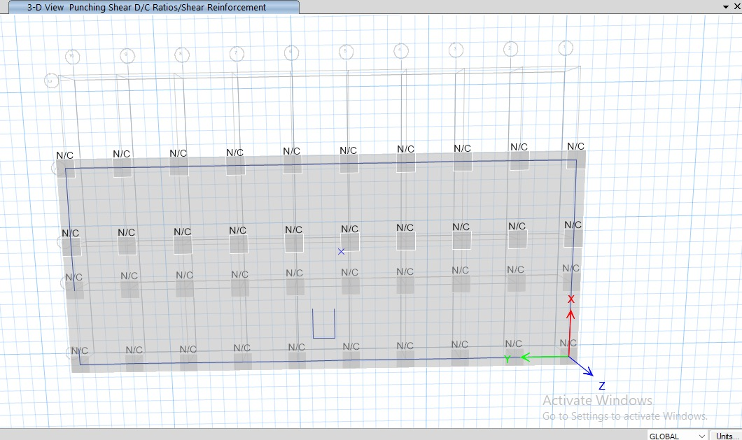
Figure 14 Punching Shear Check

